Automatic generation of traffic diversion arrangements on highways, TRAMAS

Luis Miguel Dorado López^{1*}, Carlos Ursua Lorenz², Michiel Zevenbergen³
1. Sociedad Concesionaria Autovía A4 Madrid (lmdorado@a4madrid.com), Spain
2. Sociedad Concesionaria Autovía A4 Madrid (cursua@roadis.com), Spain
3. GeoTáctica (michiel@geotactica.es), Spain

Abstract
To improve road safety on highways we are developing an application to automatically define and generate traffic diversion arrangements, called Traffic Management Assistant (TRAMAS). The application generates complete arrangements of traffic signs for different types and locations of traffic diversions. This can be done remotely, from any digital device, and can be instantly shared with roadworkers and patrols to physically install the road signs at the right position and closely following Road Administration regulations. In this paper we introduce the TRAMAS project, its functional and technical specifications, first results and conclusions.

Keywords:
Traffic diversion management
Road safety
Digital Roads

Introduction and objectives of the TRAMAS project

Government Road Administration regulations on traffic diversion arrangements
In Spain, the General Directorate of Roads, Ministry of Transport and Sustainable Mobility (MITMS) specifies road sign placements for traffic diversions for all different types of road works, highway maintenance, emergency situations and other traffic diversions¹⁾. Companies that manage the highways, such as Sociedad Concesionaria Autovía A-4 Madrid, must follow these specifications with the obvious objective to improve road safety by presenting a uniform way of road signs for highway users.

An example of these specifications can be seen in the following figure. This represents the road signs to be placed for a fixed traffic diversion on a highway with 2 lanes in each direction. It includes the initial “Roadworks ahead” sign, 700 meters before the start of the roadworks, followed by a sign of “maximum speed 100 km/h”, “Overtaking prohibited” etc. up to the signs of “Abandon the right lane”, cones along the field of the work site itself and finally the “End of the roadworks” sign.
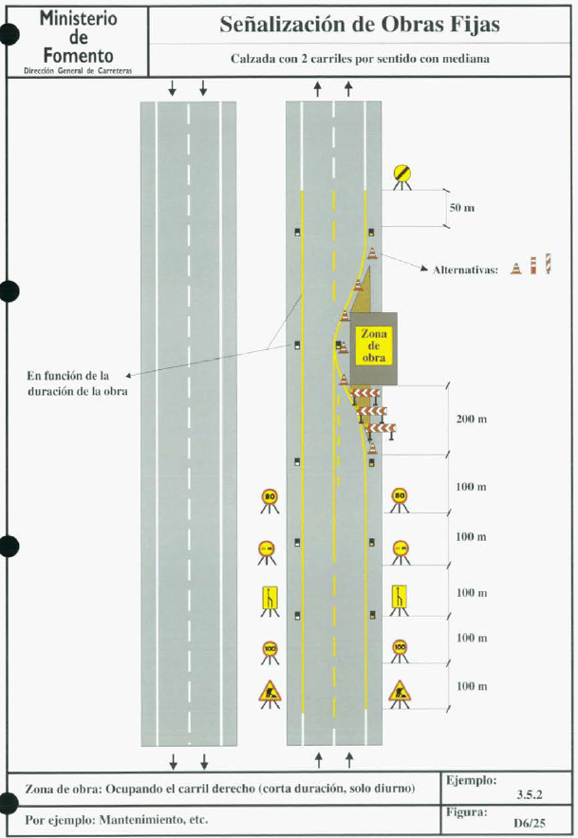
Figure 1 – Example of traffic diversion regulations

Objectives of the project
The main objectives of the project are to create a tool that:
- allows road operations engineers to easily and consistently generate traffic diversion arrangements using road signs, cones and beacons based on the specification of the MITMS, and
- allows road workers and patrols to plan and execute the placement of the required road signs.

This in turn should improve traffic diversion quality and uniformity and as such contribute to a better road safety in the case of road maintenance, road works or other situations where traffic diversions are implemented.

Required functionalities of TRAMAS

The basic functionalities of TRAMAS include the following:
- An interface with a basemap that contains a general map layer, satellite view layer, overlays with administrative subdivision, Cadastral map and buttons and selection lists for all operations executed by the application.
- Map overlays with the highway information such as kilometre points, location of the initial point of worksite, the placement of road signs etc.
- Creation of a new traffic diversion arrangement by placing a point that indicates the starting point of the worksite and then assign length of the work area, the type of traffic diversion and start- and end-date and other descriptive data.
- Generating the traffic diversion arrangement based on the type of roadwork selected by automatically created points for the locations of road signs, cones and beacons as defined by the General Directorate of Roads.
- Possibility to manually manipulate each of the road signs, cones or beacons that were generated automatically.
- Creating output such as a printed map and a list of all road signs, cones and beacons necessary for a selected traffic diversion arrangement so a roadworkers team can load equipment and prepare the execution.
- Show the real time location on a mobile device such as a tablet, using the GPS, that will allow road workers to place the road signs in their planned position.

The focus for this project is on the stretch of the A4 highway managed by Sociedad Concesionaria Autovía A4 Madrid on the A4 highway from kilometre point 3,78 to 67,5 roughly between its exit to the south of Madrid up to the municipality of Ocaña (Toledo).

Database, digital mapping and traffic diversion management

Data and digital maps in the TRAMAS database
The database for TRAMAS contains digital maps of province and municipal boundaries of the area of the project. The application also has access to the layer of Cadastral boundaries available from the Cadastral service and the orthophoto layer provided by the IGN (Instituto Geográfico Nacional). This data is available publicly as a web mapping service (WMS) based on the INSPIRE project by the European Commission²⁾.

Based on the vector data from Sociedad Concesionaria Autovía A4 Madrid we created a layer with reference points every 5 meters along the right side of the right lane of the highway. These reference points will be used for generating positions of road signs and as target locations when moving them manually. Also, the kilometre points along the highway are included.
To be able to generate traffic diversion arrangements for each type of traffic diversion, we created 2 tables. The first table contains the possible types of traffic diversions, and the second table contains the road signs with the placement of each road sign for each of these types of traffic diversion in relation to the starting point of the roadworks site. For example, for the type of traffic diversion in figure 1, the first sign of “Roadworks ahead” should be placed 700 metres before the initial point of the roadwork and on both sides of the road. The next sign, the “100km speed limit”, is placed 600 metres before, also on both sides of the road and so on. For this example of roadwork, the road sign table contains the placement of 9 different traffic signs, 5 of them on both sides of the road, as well as almost 60 cones before and after the location of the roadwork site.

To store the data for each traffic diversion arrangement, in TRAMAS, there are also two tables. In one table we store the descriptive data on the roadwork itself such as its code, name, description, type of roadwork, coordinates of its initial point, length of the roadwork and the planned begin- and end-date of the road diversion. A second table stores the locations of each of the road signs to be placed.

Managing roadwork locations and traffic diversion arrangements
The application allows a user with the correct access level to place a new road works location and subsequently automatically generate the placements of traffic signs and cones, a traffic diversion arrangement, based on the type of road work. It is possible to manually modify the default location of road signs, which might be necessary for example, if the stretch of highway leading up to the location of the road work contains an entrance ramp for vehicles.
Also, the application allows the user to place additional road signs or delete them. For the road work itself, the user can also change its name, description and start/end dates.

Road work teams and road patrols can access the application to get a listing of road signs, cones and beacons necessary to put in place the traffic diversion arrangement. Once on location and using a tablet, it is possible to switch on the real time location. This shows the location of the device on the map and allows the team to place each road sign in its proper location.

Technical setup of TRAMAS

The application is created using open-source Internet and Web technologies to ensure that it can be used on any device that can run a Web browser, such as Google Crome, Microsoft Edge or Firefox. It is developed using only opensource software and components.

Server-side elements of TRAMAS
For the project, a Web server has been created using Microsoft Windows Server with IIS. On the server we use PostgreSQL with PostGIS³⁾ as the database server. All the digital maps and tables mentioned before are stored in this database.
To generate and manage the different digital maps we use MapServer⁴⁾. This software allows the creation of a web service that generates maps on the fly based on the digital maps of the highway, the layer of reference points, locations of the road works, road signs, etc. stored in the database. The programming language PHP is used to access and manage the database.

Client-side elements of TRAMAS
The users access TRAMAS as an application running in Web browser. It basically is an HTML page that contains the complete interface and that loads JavaScript code to make everything work. For this we use HTML page elements for the layout and CSS to create the styles for all texts, buttons and other page elements. To load and display the maps we use OpenLayers⁵⁾, an open-source JavaScript library. OpenLayers contains functions to access the mapping services created on our own server with MapServer as well as other web-mapping services such as the orthophoto layer by IGN mentioned earlier.

First results and examples of TRAMAS

The interface of the TRAMAS application
In figure 2 the design of the TRAMAS application is presented. It includes a main menu on the top right, a map-area with a button pad on its right and a control panel on the left. To maximize the map-area, the control panel on the left can be hidden using the ‘<’ and ‘>’ buttons on its side.

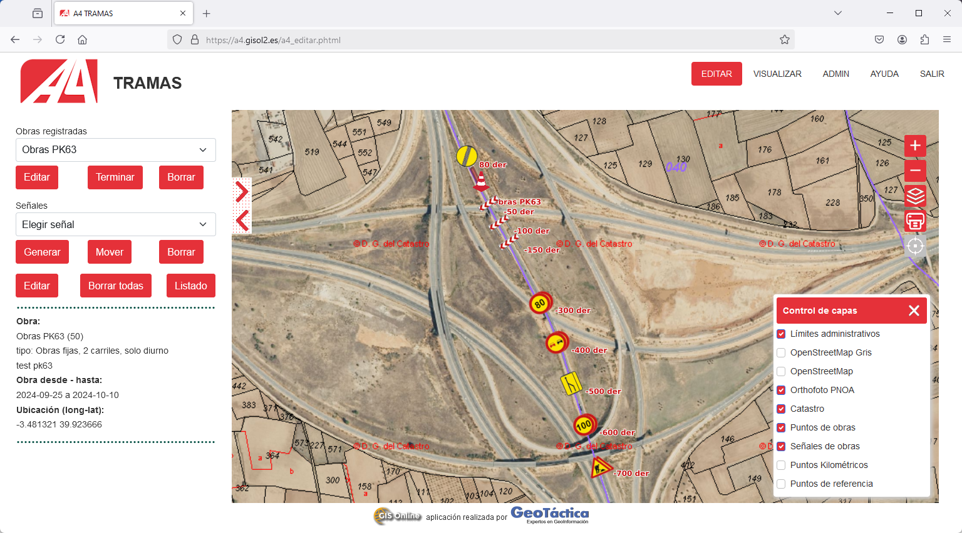
Figure 2 – Interface of TRAMAS with a traffic diversion arrangement example

The control panel on the left contains a list with all active traffic diversion arrangements for road works and allows the user to select one. Below this list there are buttons that allow the user to edit the descriptive data of an existing road work, finish or delete the selected traffic diversion. A finished traffic diversion will be maintained in the database along with all the related road signs.
When selecting a traffic diversion, the map will zoom to that area of the map and the descriptive data is displayed in the lower portion of the control panel. Also, the listing of the related road signs, if already generated, will be displayed along with a set of buttons to generate, move, delete, edit or list the road signs.
Creating the listing of the road signs will result in the download of a CSV file with a list of all the road signs, cones and beacons, their coordinates for placement and description for the selected traffic diversion. This CSV file can be directly opened, for example in Excel as shown in figure 3. This can be used by the team responsible for the placement of the road signs to prepare and load materials. This listing can also be used for the inventory management of road signs, cones and beacons.

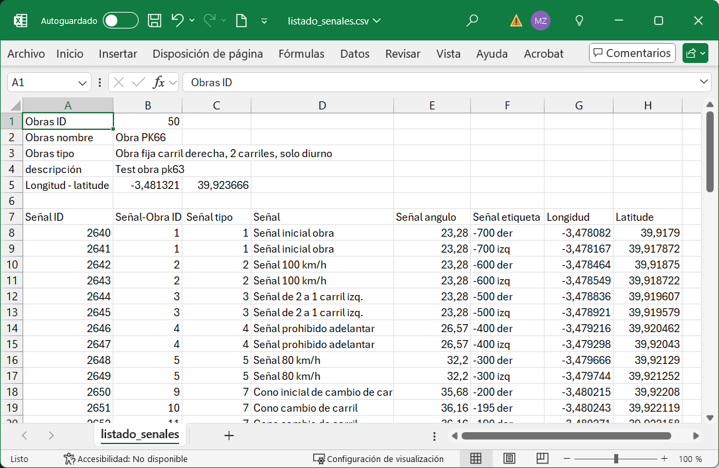

Figure 3 – Example of Excel listing of signs in a traffic diversion arrangement

The button pad on the right side in the map area, as shown in figure 2, contains buttons to zoom in and out on the map, open the layer control window, print the map and show the real time location of the device on which the application is running if it contains a GPS sensor that can be accessed.
The layer control window, shown in the lower right corner in figure 2, allows to switch the visibility of each of the layers in the map on or off. Currently we included the provincial and municipal borders, the OpenStreetMap layer, orthophoto and Cadastre layers and the layers of road work points, road signs points, kilometre and reference points.
Each of these layers has minimum zoom level on which it is still displayed. For example, if the map is showing a large area, the road work locations will be represented simply by a cone icon with a label. When the map is zoomed in to a more detailed level, the individual road signs, cones and beacons are shown if these layers are set to visible.

The print button opens a new tab window with the map exactly as it is, but without all the buttons and control panel. An example of a map is shown in figure 4. The Web browser can than be used to print the map or create a PDF file of the map.
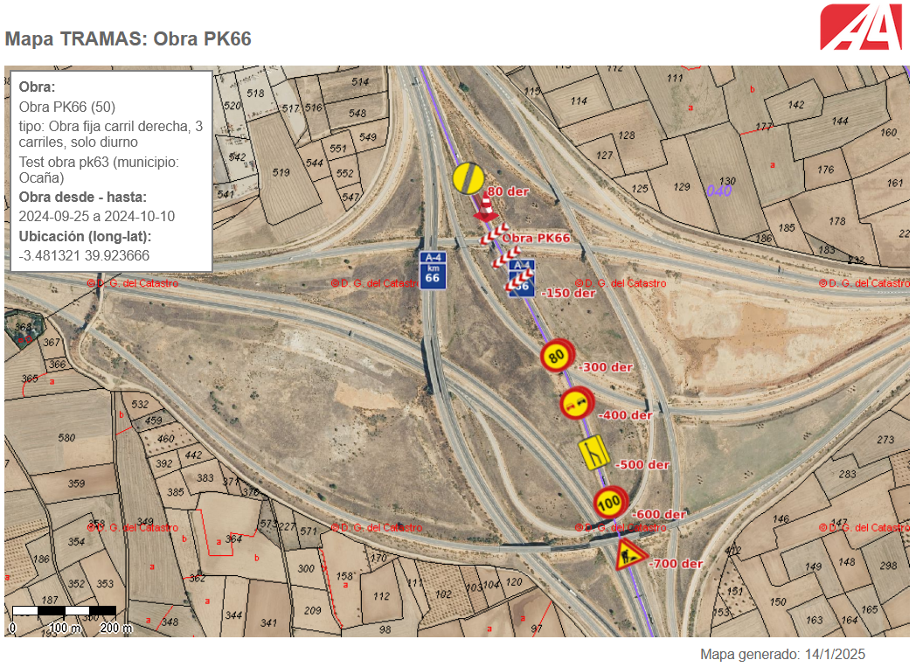
Figure 4 – Map of a traffic diversion arrangement to print

When zooming in on the map as shown in figure 2, we can see the level of detail of the generated locations of the road signs, shown in figure 5. Each individual road sign, cone and beacon becomes visible.

In figure 5 we can that the worksite is indicated with a red shading with cones along its length. In the example also the real time location of a mobile device is shown on the map. The real time location icon will move wherever the mobile device goes.

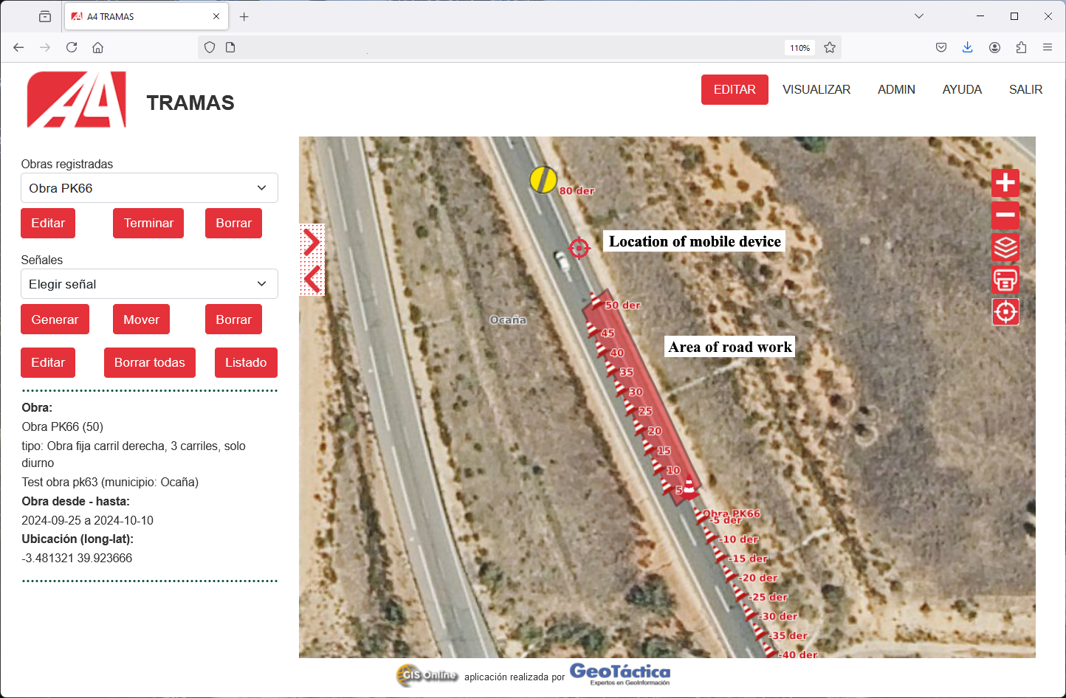
Figure 5 – Zoom to work area of a road work

The types of road works included and future extensions
In the first stage of the development, we have included 4 different types of traffic diversion. The example in figure 1 is a road work that needs a traffic diversion that forces road users to abandon the right lane of a 2-lane highway. Based on that example we also created traffic diversion type for freeing of the right lane of a 3-lane and a 4-lane highway. We also added an emergency traffic alert that places road signs that only alerts highway users to an emergency without blocking the highway itself.

Adding a new type of traffic diversion would encompass adding records to the table containing the types of traffic diversions and add the corresponding records in the table of road sign locations for the placement of each road sign, cone or beacon ahead and after the worksite. Also, the many images of road signs and beacons must still be added.

Finally, the management of traffic diversions created in the application must still be further developed. In the first version of TRAMAS the application simply shows all active traffic diversions in the database. When a user marks a traffic diversion as finished, its is not shown in the listing anymore. It will be necessary to create a history of traffic diversions and create functionality that allows the user to select active or historic traffic diversions.

Conclusions

The first version of TRAMAS has been developed, tested and installed on a server at Sociedad Concesionaria Autovía A4 during a 3-month period. The application allows the creation of traffic diversion arrangements for only a few types of road works, but this can be extended rapidly.

The way in which the types of traffic diversions and the related locations of road signs are stored in separate tables in the database allows for a very flexible way of adding new types of traffic diversions. The application and database can also be used for different types of roads and in different countries with different regulations with only the need to adjust the traffic diversion and related road signs tables.

TRAMAS creates the basis for a uniform way of traffic sign placement for every type of traffic diversion. This will create more recognizable situations for road users and reduces uncertainties. It will therefore contribute to road safety for both road users and roadside workers.

Road workers have direct and detailed access to where and how road signs should be located. On a mobile device they can see the location of the road signs and their own location on the map in real time. This will improve the accuracy of road sign placement. Each team can prepare an exact inventory of road signs necessary for putting in place a road diversion arrangement which will lead to a more secure and quick execution time. Also, working in this way increases accountability of use of equipment and allows for a better management of equipment.

The usefulness of the data that is created with TRAMAS can go beyond just the company that is managing the highway. The data might be used by the Road Administration and even Emergency Services. Road Administration can use the data for control and inspection. Emergency Services can use the data to always have an up-to-date operational overview of the highway situation in general. Additionally, having the traffic diversion arrangement in a shared digital format may allow in the future the deployment of connected car applications to inform drivers when approaching road works.

References
- Dirección General de Carreteras, Ministerio de Transportes y Movilidad Sostenible (1997). Manual de ejemplos de señalización de otras fijas.
- European Commission (2010). Commission regulation No 1089/2010. Published on the European Commission website.
- PostGIS PSC & OSGeo (Open Source Geospatial Foundation). About PostGIS, as published on the PostGIS website, https://postgis.net.
- OSGeo (Open Source Geospatial Foundation). Welcome to MapServer, as published on the MapServer website, https://mapserver.org/.
- The OpenLayes project. Overview of OpenLayers, as published on the OpenLayers website, https://openlayers.org/.

